**PAPER BAG MACHINE**

**A Course Project report Submitted in partial fulfillment of the Academic requirements for the award of the degree of**

**Bachelor of Technology**

Submitted by

**1.V. BHUVANA SRI-------[19H51AO5J2]**

**2.V. THRISHALI ----------[19H51A04H9]**

**3.Y. SADA SHIVA ---------[19H51A04J0]**

**4.S. RAKESH KUMAR----[19H51A05J1]**

**UNDER THE COURSE**

**ENGINEERING EXPLORATION & PRACTICE**



**CENTRE FOR ENGINEERING EDUCATION RESEARCH**

**CMR COLLEGE OF ENGINEERING & TECHNOLOGY**

**(Autonomous)**

**(NAAC Accredited with ‘A’ Grade & NBA Accredited)**

**(Approved by AICTE, Permanently Affiliated to JNTU Hyderabad)**

**KANDLAKOYA, MEDCHAL ROAD, HYDERABAD-501401**

**2019-20**

**CENTRE FOR ENGINEERING EDUCATION RESEARCH**

**CMR COLLEGE OF ENGINEERING & TECHNOLOGY**

**(Autonomous)**

**(NAAC Accredited with ‘A’ Grade & NBA Accredited)**

**(Approved by AICTE, Permanently Affiliated to JNTU Hyderabad)**

**KANDLAKOYA, MEDCHAL ROAD, HYDERABAD-501401**



**+++**

**e**

**CERTIFICATE**

This is to certify that the report entitled **“PAPER BAG MACHINE”** is a bonafide work done by, **1. V. Bhuvana Sri (19H51A05J2), 2. V. Thrishali (19H51A04H9), 3. Y. Sadashiva (19H51A04J0), 4. S. Rakesh Kumar (19H51A05J1)** of I B.Tech in partial fulfillment of requirements for the award of the degree of Bachelor of Technology, submitted to Centre for Engineering Education Research ,CMR College of Engineering & Technology, Hyderabad during the Academic Year 2019-20.

**(Names of the project coordinators) D. Soujanya**

**1. Mr. CH V N S Pavan Pushya HEAD OF CEER**

**2. Ms. Archana Prakash**

**3. Mr. Nageshwar Reddy**

**DECLARATION**

We, the students of I B.Tech of Centre for Engineering Education Research , CMR COLLEGE OF ENGINEERING AND TECHNOLOGY, Kandlakoya, Hyderabad, here by declare, that under the supervision of our guide course coordinators, we have independently carried out the project titled “Title” and submitted the report in partial fulfillment of the requirement for the award of Bachelor of Technology in by the Jawaharlal Nehru Technological University,Hyderabad (JNTUH) during the academic year 2019-20.

Name Roll Number Signature of the students

1. V Bhuvana Sri 19H51A05J2

2.V Thrishali 19H51A04H9

3.Y Sadashiva 19H51A04J0

4.S Rakesh Kumar 19H51A05J1

**ACKNOWLEDGEMENT**

We would like to thank our faculty members: Mr. CH V N S Pavan Pushya, Ms. Archana Prakash, Mr. Nageshwar Reddy.

We would also like to thank our lab Assistant N. Praveen. We are obliged and grateful to thank D.Soujanya madam Head(CEER), CMRCET, for her cooperation in all respects during the course.

We would like to thank the Principal of CMRCET, Dr.V.A. Narayana, for his support in the course of this project work.

Finally, we thank all our faculty members and Lab Assistants for their valid support.

We own all our success to our beloved parents, whose vision, love and inspiration has made us reach out for these glories.

**TABLE OF CONTENTS**

|  |  |  |  |
| --- | --- | --- | --- |
| **CHAPTER** | | **DESCRIPTION** | **PAGE No** |
|  |  | Abstract | 5 |
| 1 |  | Introduction | 5 |
| 2 |  | Literature Review | 6 |
| 3 | 3.1 | Problem Statement | 7 |
|  | 3.2 | Objective | 7 |
|  | 3.3 | Requirement Analysis | 8-9 |
|  | 3.4 | Methodology | 9 |
| 4 |  | Implementation | 9-16 |
|  | 4.1 | Conceptual Design | 9 |
|  | 4.2 | Block Diagram | 10-12 |
|  | 4.3 | Flow Chart | 13 |
|  | 4.4 | Implementation code | 14-16 |
| 5 |  | Appendix | 17-18 |
|  | 5.1 | Results And Discussions | 17 |
|  | 5.2 | Conclusion | 17 |
|  | 5.3 | References | 17-18 |

**ABSTRACT**

We have designed a low-cost, compact paper-bag making machine designed to produce paper-bags and minimize the usage of plastic bags for an eco-friendly society. The system being semi-automatic is capable of producing single-size paper-bags from A3 size papers (Our model is restricted to A3 size papers alone). The project has been implemented by making use of Arduino Uno micro-controller, IR sensor, actuators, DC motors and servo-motor. The proposed model can be operated in small-scale industries or homes for producing paper-bags and we believe it can reduce the usage of polythene bags.

1. **INTRODUCTION**

In current situation, the use of plastic bags for every single work has become a usual thing. Right from buying grocery from market to shopping in malls everywhere plastic bag is been used. The use of plastic bags across the country has increased, and it is continuously increasing day by day. Plastic, though it is an amazing creation which has helped us in manifold ways, it is non-biodegradable. It continues to pollute the environment and imposes a hazardous threat to many animals as well as heritage sites.

Unlike plastic, once paper is made, it can be recycled and used to create more paper goods. Bags made from paper are bio-degradable and hence highly environment friendly than plastic bags.

However, existing paper bag machines are expensive and bulky. So we’ve come up with a solution of a model which is inexpensive and compact.

**2. LITERATURE REVIEW**

[1] “Automated Paper Bag Making Machine” For this model, they have design and develop an automated Paper bag making machine for different objectives and which integrate all the objectives together using Arduino. Their project is feasible, high efficiency and high robustness. It has automated paper envelope machine in order to reduce the man power and to increase the efficiency and quality of the product and ultimately to increase the preparedness to face emergency situations. Their system contains the parts which are easily available.

[2]“An Optimized Embedded System for Automated Paper Bag Production” For this model, they have used micro-controller based design approach which has kept the cost of the system significantly low as compared to PLC based designs. They have used recycled approximately A4 size which is feed into machine with the help of two rollers they have used two IR sensors one is used for applying adhesive and the second sensor is triggered which signifies that middle portion of the page is at the center of the other roller and a blade is applied to fold a paper into two halves and passed through a roller so that the glue placed on one half portion of the page gets stick to other half of the page which gives a nice half A4 size paper bag. The proposed system has required less manpower than traditional method of manufacturing paper bags. Any kind of paper quality can be used for production whether it is virgin or recycled. Any size of paper bag can be produced by adjusting the roller length.

[3] “Portable Paper-Bag Making Machine” In this paper, they have come up with a low-cost semi-automatic paper bag making machine. They have used Indian clone of OWI Robotic Arm, the total system cost is INR 3000. Currently their system can produce 1 paper-bag per minute. This is because of the 5V DC geared motor used in entire system. Also glue needs to be replaced frequently. Further one human assistance is required. However, the machine can be deployed in small-scale industries, homes, etc. and their paper-bag can be used for carrying vegetables and fruits, for small stationaries, can be used in medical shops for carrying medicines, etc.

**3.1 PROBLEM STATEMENT**

* Plastic consumption should be reduced as per the recent government policy and organisations are shifting to jute-based bags. A portable machine that can design paper bags with low cost is required.

**3.2 OBJECTIVES**

1. To minimize the human effort.

2. To develop simple mechanism to perform the operation.

3. To increase the efficiency and quality of the products.

4. To analyze the demand of paper bag.

5. To develop a machine which can be used mostly where there is shortage of electricity.

6. To increase the production rate with the less cost.

**3.3 REQUIREMENT ANALYSIS**

COMPONENT USED

1. Wooden ply board(for base or frame of the machine)

2. DC geared Motors(2 normal motors 100rpm)

3. PVC pipes(for roller)

4. Bearing(used at the end of roller for rolling)

5. Servo motor(for folding the glued paper bag at the folding station)

6. IR Sensor(for detecting paper movement near the gluing station)

7. Jumper wires

8. Glue sticks

9. Arduino UNO Micro controller

10.Actuator(for gluing the edges of the paper)

11.Track belt(for conveyor belt)

COMPONENT SPECIFICATIONS:

A)MOTOR:

1) 30RPMJOHNSONS 12V DC:

Features

a) 100RPM 12V DC motors with Gearbox

b) 6mm shaft diameter with internal hole

c) 2kgcm torque

d) No-load current = 60 mA(Max), Load current = 300 mA(Max)

e)Power:2.4 W power is selected for the following 100rpm motor

B)BELT

a) Materiel: Rubber

b) Length:1760mm(end to end)

c) Thickness:1.5mm

**3.4 METHODOLOGY**

This project aimed at making the paper bag manufacturing unit which has a compact design, is cheap, and has reduced maintenance.

Initial survey of design was done on internet. A preliminary design was made which was based of operations to be performed and literature study. This design was later been validated by our guide considering all the parameters. Each workstation had some mechanisms. These mechanisms were designed after intense thinking and a number of group discussions.

The designing of setup is to be done considering into account its practicality of performing operations.

**4. IMPLEMENTATION**

**4.1 CONCEPTUAL DESIGN**

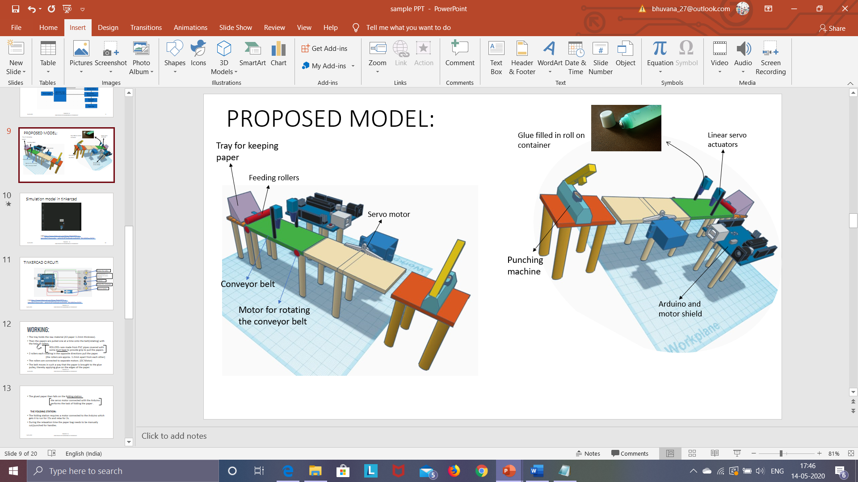



Paper rollers

Ready paper bag

Paper fold and paste station(servo motor)

Gluing station(actuators)

Paper IN

IR Sensor

**4.2 BLOCK DIAGRAM**

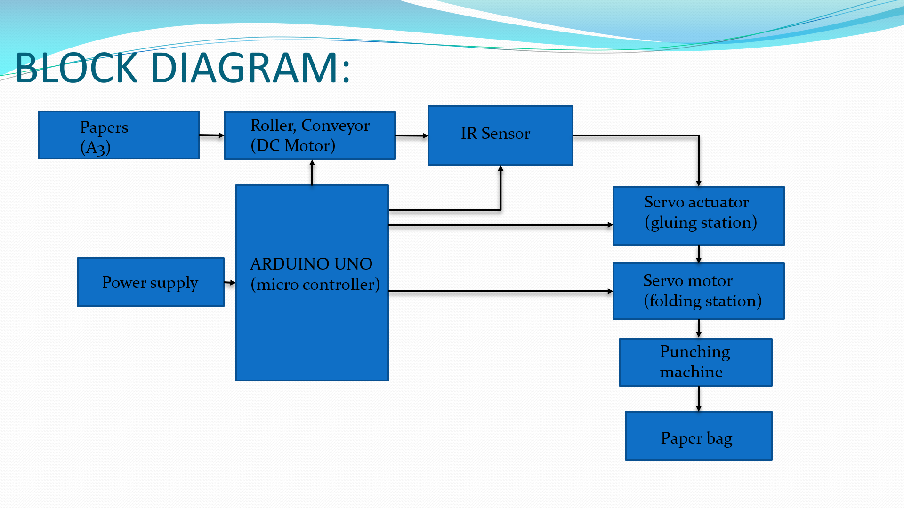

A Brief description about each block:

1.**Paper**

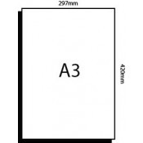

The dimensions of an A3 size paper are: 297X420 mm.

The paper is obtained from eductional institutions after use, and can reduce the cost of raw material.

The paper is futher very durable, and can withstand the load.

**2.Rollers**

The PVC pipe of diameter 6 cm is used to pull the paper onto the conveyor belt by using it to make rollers.

The length of the pipe can be fixed as slightly larger than the width of the paper.

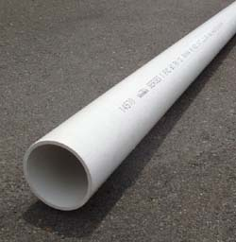

**3.Conveyor**

The conveyor belt is mainly used to transport the paer from the tray to the glue actuators, later on to the folding station.

However, after the paper is folded the paper has to be manually taken to the punching machine, where holes are punched onto the bags.



Belt attached to the rollers forms the conveyor belt.

**4.IR Sensor**

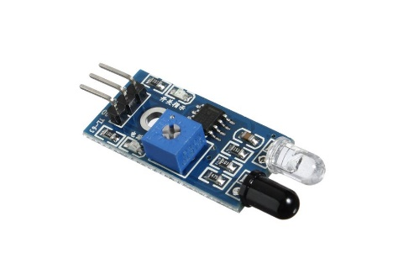

The IR sensor is placed at the glue actuators, it senses the position of the paper and then the actuators can slide and glue gets applied to the oppsite edges of the paper.

**5.Servo actuator**

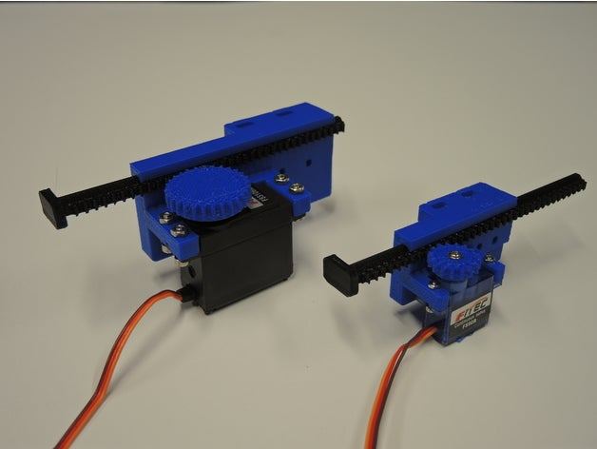

The sliding servo actuator used here has a glue roll on container clamped onto its pusher, the pusher glides upon getting signals from the IR sensor and the glue gets applied onto the edges of the paper.

**6.Servo motor**

The servo motor present at the folding station fold the paper so that the glued edges get stuck and after this stage the product is the paper bag without handles.

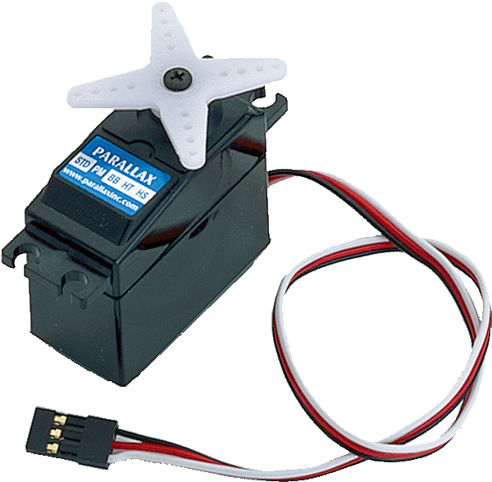

[This Photo](http://asoreytecnoloxia.blogspot.com/2015/03/practicando-con-s4a-5-parte.html) by Unknown Author is licensed under [CC BY](https://creativecommons.org/licenses/by/3.0/)

**7.Punching machine**

The punching machine is used to make holes to the product obtained at the folding station, then threads are manually attached to make handles for the paper bag



**8.Arduino UNO microcontroller**

The Arduino UNO microcontroller is used to make the complete fabrication of the paper bags an easy and cost efficient process, it is programmed to allow various processes to take place in the manufacturing of the paper bags.

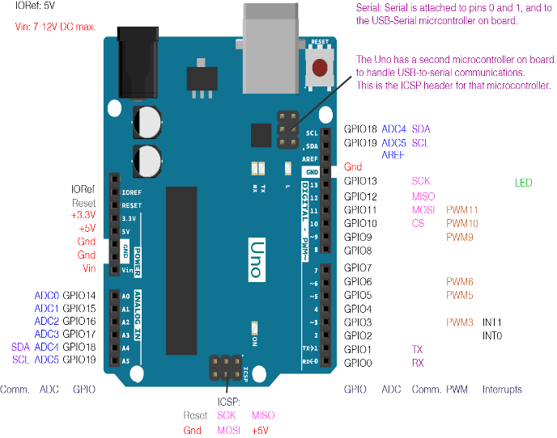

**4.3 FLOW CHART**

A3 Paper

Paper being fed into the rollers

Paper being pulled onto the conveyor belt

IR sensors detecting the paper

Application of glue onto the edges of the papers with the help of actuators

Folding station operated by servo motors

Punching machine used to make holes

Attaching handles

Finished paper bag

**4.4 IMPLEMENTATION CODE**

#include <Servo.h>

Servo myservo; // create servo object to control a servo

// twelve servo objects can be created on most boards

int pos = 0; // variable to store the servo position

int value1;

int value2;

int IRSensor = 10;

void setup()

{

pinMode(13, OUTPUT);

pinMode(1, OUTPUT);

myservo.attach(2);

pinMode(A0,INPUT);

pinMode(A1,INPUT);

pinMode (10, INPUT);

}

void loop()

{

digitalWrite(13, HIGH);

digitalWrite(1, HIGH);

delay(2000);

digitalWrite(1, LOW);

delay(3000);

int statusSensor = digitalRead (IRSensor);

if (statusSensor == 1)

{

value1 = analogRead(A1); //Read and save analog value from potentiometer

value1 = map(value1, 0, 1023, 0, 255); //Map value 0-1023 to 0-255 (PWM)

analogWrite(13, value1); //Send PWM value to

//delay(10); //Small del

value2 = analogRead(A0); //Read and save analog value from potentiometer

value2 = map(value2, 0, 1023, 0, 255); //Map value 0-1023 to 0-255 (PWM)

analogWrite(1, value2); //Send PWM value to

delay(10); //Small delay

}

for(pos = 0; pos <= 180; pos += 1) // goes from 0 degrees to 180 degrees

{ // in steps of 1 degree

myservo.write(pos); // tell servo to go to position in variable 'pos'

delay(10); // waits 10ms for the servo to reach the position

}

for(pos = 180; pos>=0; pos-=1) // goes from 180 degrees to 0 degrees

{

myservo.write(pos); // tell servo to go to position in variable 'pos'

delay(10);

}

}

**5. APPENDIX**

**5.1 RESULTS AND DISCUSSIONS**

1. Automation of paper bag production is totally feasible.

2. It requires lees manpower than traditional method of manufacturing paper bags.

3. Any kind of paper quality can be used for production whether it is virgin or recycled.

4. Any size of paper bag can be produced by adjusting the roller length.

5. The rate of production can be increased by using such an automated process.

**5.2 CONCLUSIONS**

Plastic is harmful for our environment, we have paper bags as an alternative for this. We have design and develop an automated Paper bag making machine for different objectives and to integrate all the objectives together using microcontroller.

Drawing sheets(A3) which are a waste for many educational institutions will be used as a raw material for manufacturing paper bags due to which its raw material cost is reduced. The machine is cheaper, compact and portable than currently available paper bag manufacturing machines.

**REFERENCES**

[1].Geared DC motors (webpage) - https://www. engineers garage. com/insight/how-geared-dc-motor-works

[2]. L293D datasheet - http://www. ti.com/lit/ds /symlink /l293.pdf

[3]. Programmer‟s Notepad (webpage) - https:// en.wikipedi a.org/wiki/Programmer%27s_Notepad

[4]. WINAVR (webpage) - http://www.webring.or g/l/rd?ring= avr;id=59;url=http%3A%2F%2Fwinavr%2Esourceforge%2En et%2F

[5]. Arduino IDE (webpage) - https:// www. arduino .cc/e n/guide/environment